Knowledge Base Web Portal Screen shorts

1. New Issues Tab: Main Menu and Tabs .

In this tab we can add new issues to the KB database which can be searched and modified late stages, this tab show recently added issues by the authorized user.

Please let us know what all additional tasks need to be added in to this tab.

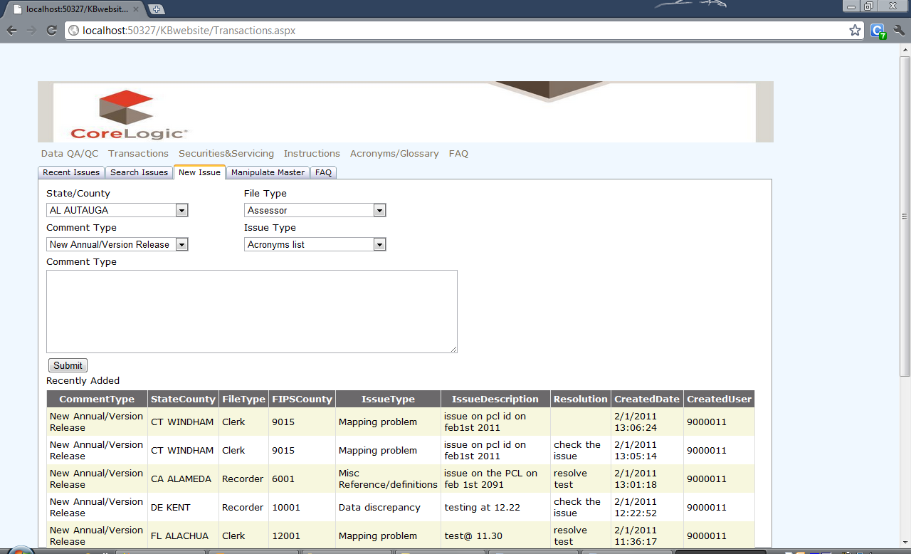

Please Specify Tab order and what all tabs required

Please Specify what kind of Main Menu Item has to come here .

Fig:1.1

New Issues Tab: Fields

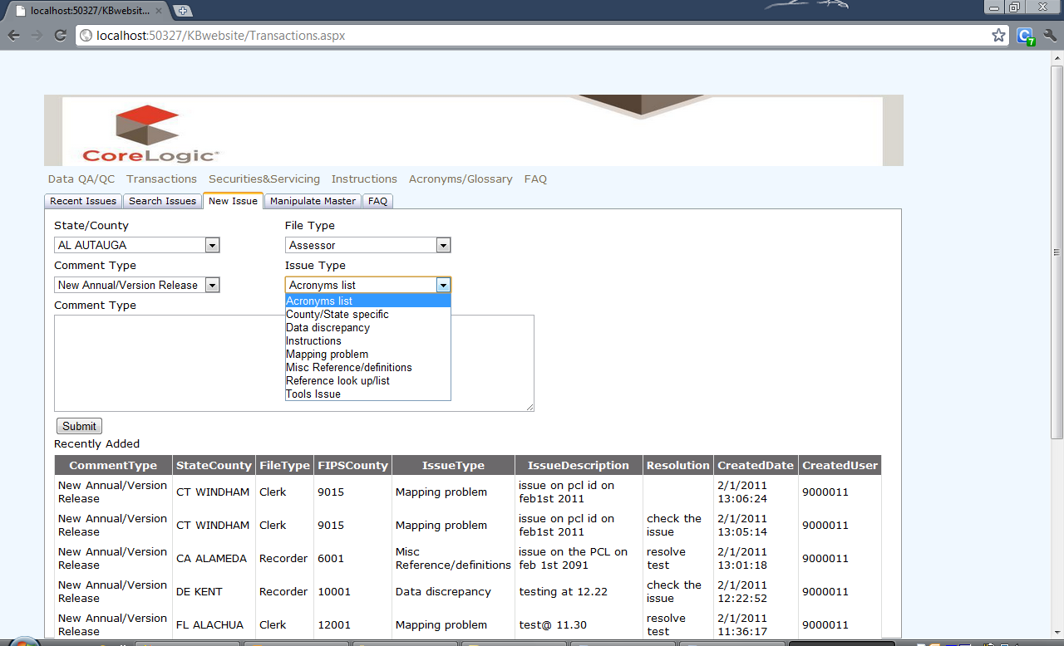

Please specify the Fields which will appear in this New Issue Tab.

Please give sample data for the each Field so we can build **Master Data** .

eg:File Type(Assessor,clark,Recorded)

Issue Type(Acronyms list,instructions,mapping problem,tools issue,etc)

Fig:1.2

1. Search Issues Tab: This tab can be used to search the issues to update or modify each or multiple issues be double clicking the issue .only authorized user can perform this operations.

Please let us know what all additional tasks need to be added in to this tab.

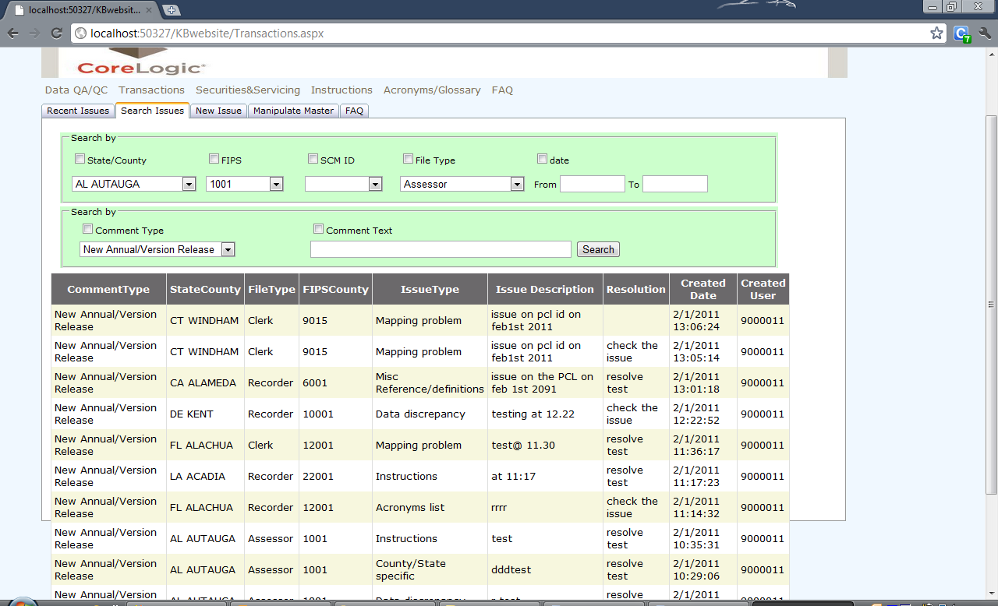

Please specify all the search criteria’s , what all search fields to be added

Fig:2.1

1. Recent Issues Tab: we can check Recent issues (status , Response, check deeper into the issue tree ). Please let us know additional what all additional tasks need to be added in to this tab.

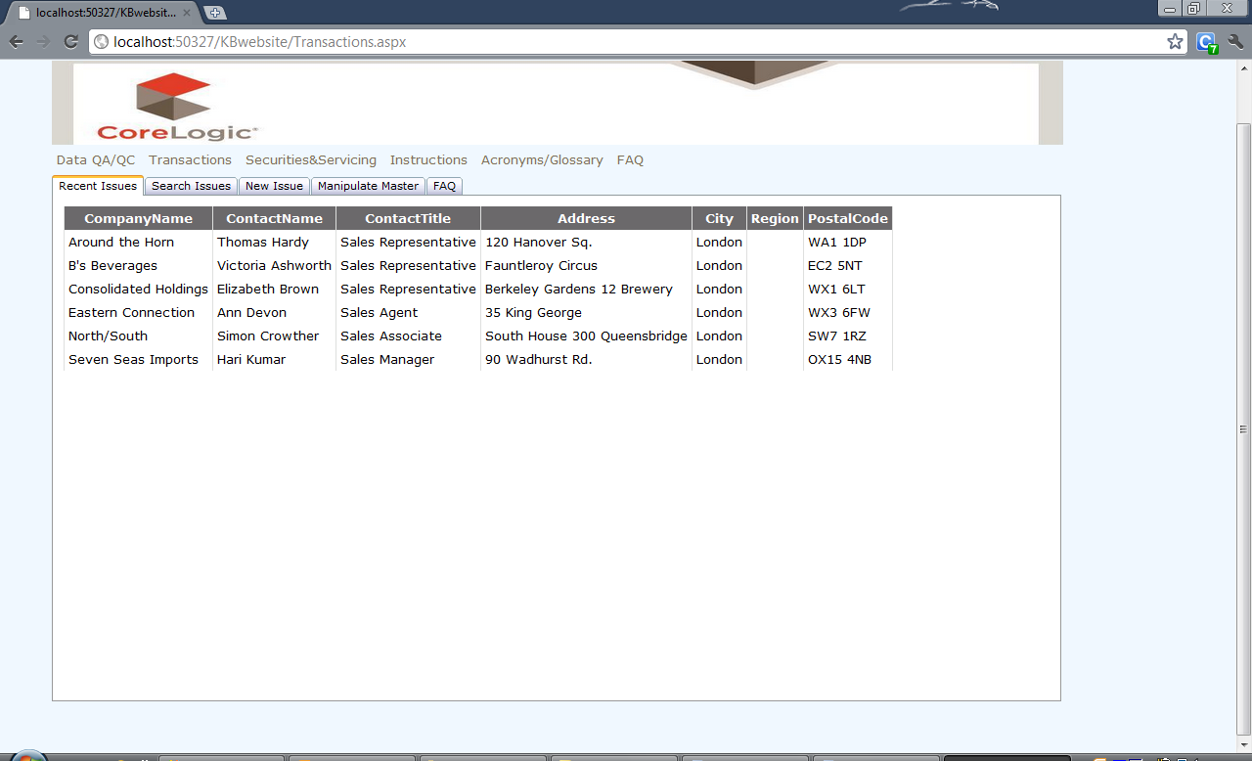

This is Recent Issues Tab sample.

Let us know what tasks to add to this page